Dr. Alok Kumar
Monopolistic Competition
Monopolistic competition is a form of imperfect competition and can be found in many real world markets ranging from clusters of sandwich bars, other fast food shops and coffee stores in a busy town centre to pizza delivery businesses in a city or hairdressers in a local area.
Small-scale nurseries and care homes for older people might also fit into the market structure known as monopolistic competition
Monopolistic competition is similar to perfect competition, some economist regard it as more realistic, because the products are differentiated
Short run price, output and profit under monopolistic competition
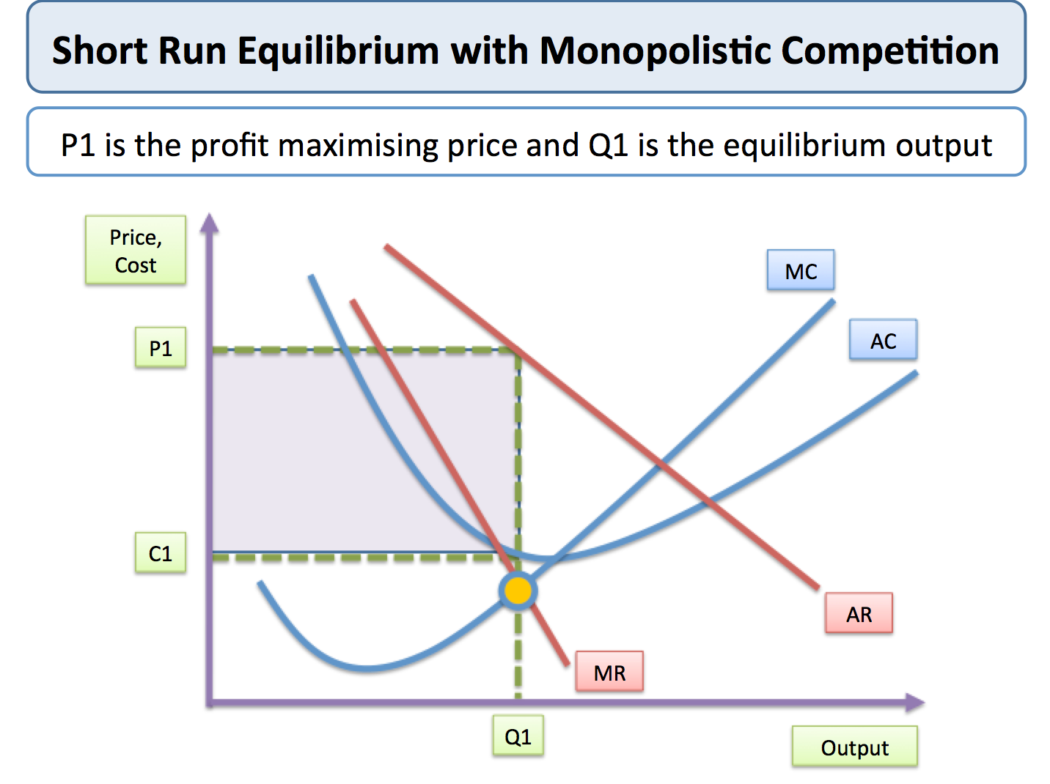
The assumptions of monopolistic competition are as follows - as you check through them, look to see the differences between monopolistic competition and perfect competition.
- There are many producers and many consumers - the industry concentration ratio is low
- Consumers perceive that there are non-price differences among products i.e. there is product differentiation – competition is strong, plenty of consumer switching takes place
- Producers have some control over price - they are “price makers" not “price takers" but the price elasticity of demand is higher than it would be under a situation of monopoly
- The barriers to entry and exit into and out of the market are low
In the short run the profits made by businesses competing in this type of market structure can be at any level - in our example above the business is making supernormal profits indicated by the shaded area.
Strong brand loyalty can make consumer demand less sensitive to price i.e. lowering the PED
Unlike monopoly, there are no barriers to entry. This means that the short run supernormal profit attracts new producers into the market, and so normal profits only are made in the long run equilibrium
As more firms enter the market, the demand curve facing any existing firm moves to the left (as consumers choose the products offered by new or alternative companies).
The demand curve continues to move to the left until it is tangential to the AC curve. At this point, the monopolistically competitive firm is at its profit-maximising level of output (because MR = MC) but is making normal profit (because AR = AC)
In the long run equilibrium the representative firm in the market is making normal profits
The reality is that a stable equilibrium is never reached - new products come and go all of the time, some do better than others. Existing products within a market will typically go through a product life cycle that affects the volume and growth of sales.
One of the implications of monopolistic competition is that an inefficient outcome is reached.
- Prices are above marginal cost – meaning that the equilibrium is not allocatively efficient
- Saturation of the market may lead to businesses being unable to exploit fully economies of scale - causing average cost to be higher than if less firms and products were in the market
- Critics of heavy spending on marketing and advertising argue that much of this spending is wasted and is an inefficient use of scarce resources. The debate over the environmental impact of packaging is linked strongly to this aspect of monopolistic competition
The principles of minimum differentiation
This idea states that it is often rational for businesses when entering a market to make their products as close as possible to rivals including for example the location of their main market place for customers.
